* In order to run tests in parallel:

1. pip install pytest-xdist
2. pytest -n <num_of_processors> <filename.py>

* in order to run tests by groups:

1. pytest -m <Groupname> -v <filename.py>

* in order to run test by groups & in parallel:

pytest -m >GroupName> -v -n <num_of_processors> <filename.py>





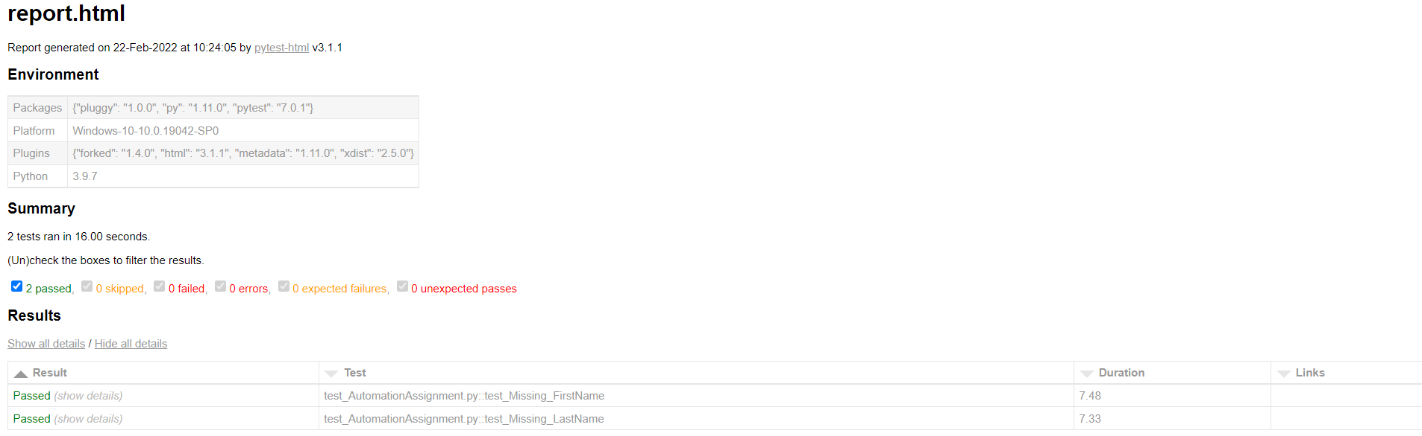

In order to generate junit report:



